

HLD-v0.1 – Digitalization of Admissibility - OneID High-Level Design

Document Control
This document is available in two forms, controlled and uncontrolled. The controlled variant is maintained electronically and accessed by authorized persons of IATA IT Document Library on Sharepoint. Uncontrolled variants will be in Confluence page.

Contents
Digitalization of Admissibility - OneID High-Level Design 1
Document Control 1
Introduction 4
Background 5
Business and Design Requirements 5
Scope 5
In Scope 5
Out of Scope 5
Design Factors 6
Design Risks 6
Design Dependencies 6
Design Assumptions 6
Design Decisions 6
Workload Design 7
2.1. Overview 7
2.1.1. Current Solution 7
2.1.2. Proposed Solution 8
2.1.3. High Level Solution Diagram 8
Information Design 10
3.1. Information Domain decomposition 10
Subject Areas 10
Data Input and Output 17
Stored Datasets 18
3.4. Externalized Datasets 18
Appendices 23
Appendix A: Additional Document References 23
Ref 23
Document 23
Status 23
Version 23
Appendix B: Terminology 23

Introduction
- Background: Explanation of the need for a digital identity and admissibility solution.
- Business and Design Requirements: Overview of the requirements to digitalize the admissibility process using OneID.

Scope
- In Scope: Details what aspects of the admissibility process are covered by OneID.
- Out of Scope: Lists any elements not addressed by the OneID solution.

Design Factors
- Design Risks: Potential risks in the design and how they will be mitigated.
- Design Dependencies: External and internal dependencies necessary for the design.
- Design Assumptions: Assumptions made during the design process.

Workload Design
- Overview: High-level overview of the current solution versus the proposed solution.
- High-Level Solution Diagram: Graphical representation of the proposed OneID solution.

Information Design
- Information Domain Decomposition: Breakdown of information domains within the solution.
- Subject Areas: Specific areas of focus within the solution.

Technology and Infrastructure Design
- Deployment: How the OneID solution will be deployed within the existing infrastructure.
- Technology Stack in Solution: Technology components used in the solution.
- Infrastructure Used: Details of the infrastructure that will support OneID.

Security Design
- Access Control: How access to the OneID system will be controlled.
- Role-Based Access: Details on roles and permissions within the OneID system.

Testing Considerations
- Pre-Production Environment: The environment setup for testing the OneID solution.

Design Dispensations
- Details on any dispensations required due to deviations from standard architecture principles or policies.

Appendices
- Appendix A: Additional Document References: References to additional documentation related to OneID.
- Appendix B: Terminology: Definitions of key terms used in the document.

2.1.3. High Level Solution Diagram
The below figure depicts the information flow with the system
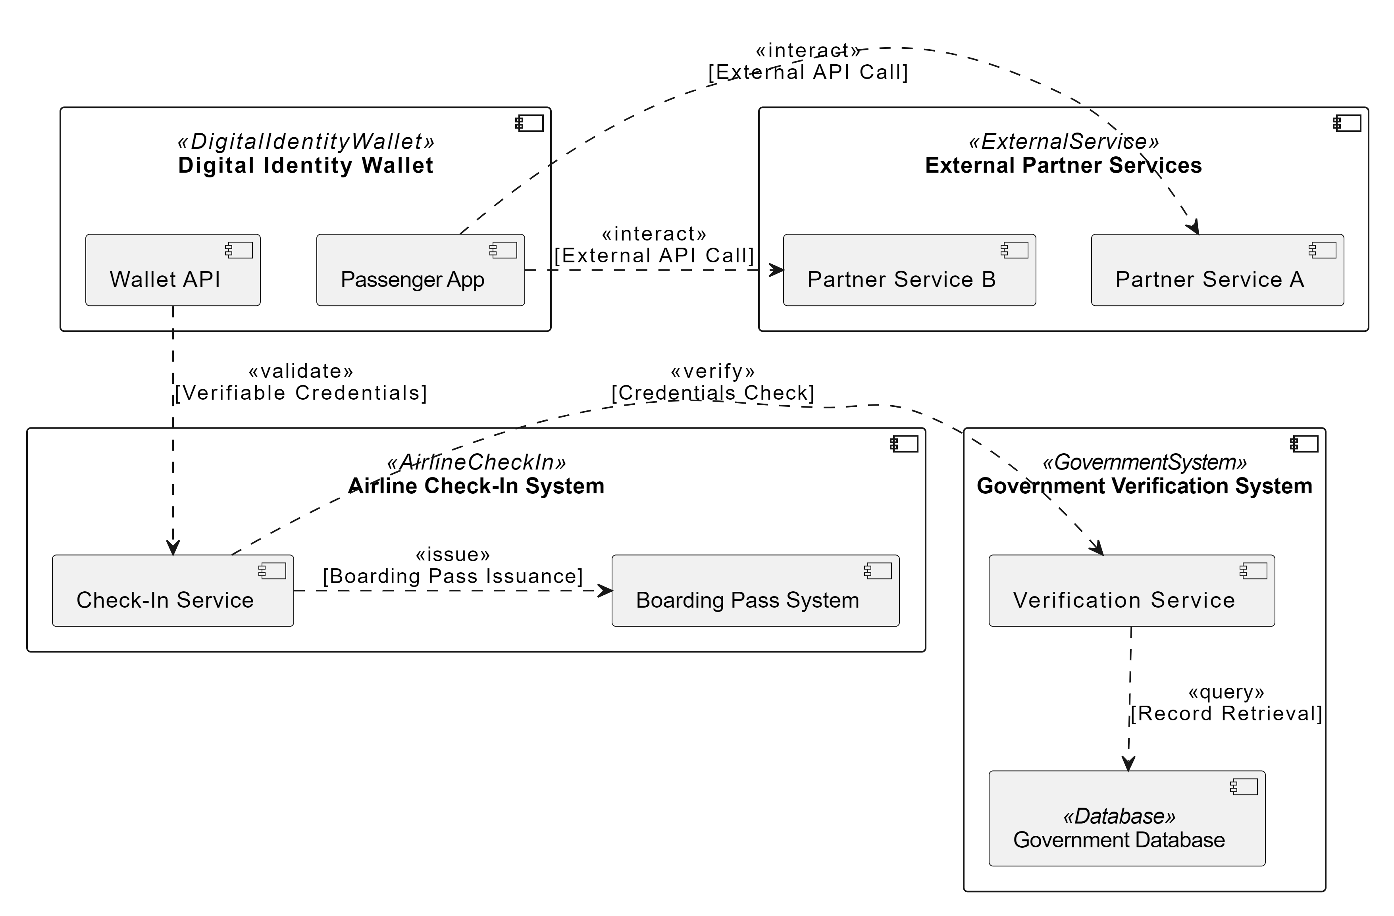

Information Design

3.1. Information Domain decomposition
The information domains that will be modelled and physically as part of solution are depicted below:

Subject Areas
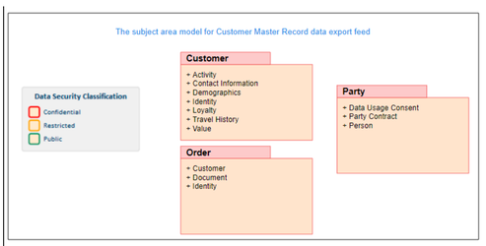
Subject Area Model

3.1.3. Business Information Map
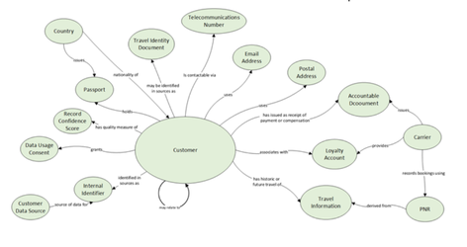
Following Attribute are related to OneId

le Name/View Name | Attribute/Column Name(View Level) | Data Type | Data Length | Primary Key (Yes/No) | PII Data (Yes/No) | Definition | Data Classification | High Level Dataset Mapped
PassengerProfile | PassengerID | VARCHAR | 36 | Yes | Yes | Unique identifier for a passenger | Confidential | Passenger Data
PassengerProfile | FullName | VARCHAR | 255 | No | Yes | Full name of the passenger | Confidential | Passenger Data
PassengerProfile | DateOfBirth | DATE |  | No | Yes | Birth date of the passenger | Confidential | Passenger Data
DigitalDocuments | DocumentID | VARCHAR | 36 | Yes | Yes | Unique identifier for a document | Confidential | Travel Documents
DigitalDocuments | PassengerID | VARCHAR | 36 | No | Yes | Reference to the passenger ID | Confidential | Travel Documents
DigitalDocuments | DocumentType | VARCHAR | 50 | No | No | Type of document (e.g., passport, visa) | Public | Travel Documents
DigitalDocuments | IssuingCountry | CHAR | 2 | No | No | ISO code of the country issuing the document | Public | Travel Documents
DigitalDocuments | ExpiryDate | DATE |  | No | No | Expiry date of the document | Public | Travel Documents
CheckInTransactions | TransactionID | VARCHAR | 36 | Yes | No | Unique identifier for a check-in transaction | Confidential | Transaction Records
CheckInTransactions | PassengerID | VARCHAR | 36 | No | Yes | Reference to the passenger ID | Confidential | Transaction Records
CheckInTransactions | FlightNumber | VARCHAR | 10 | No | No | Flight number for which check-in is being done | Public | Transaction Records
CheckInTransactions | CheckInStatus | VARCHAR | 50 | No | No | Status of the check-in (e.g., checked-in, pending) | Public | Transaction Records
BoardingPasses | BoardingPassID | VARCHAR | 36 | Yes | No | Unique identifier for a boarding pass | Confidential | Boarding Records
BoardingPasses | TransactionID | VARCHAR | 36 | No | No | Reference to the check-in transaction ID | Confidential | Boarding Records
BoardingPasses | SeatNumber | VARCHAR | 5 | No | No | Assigned seat number on the boarding pass | Public | Boarding Records
GovernmentVerifications | VerificationID | VARCHAR | 36 | Yes | No | Unique identifier for a verification record | Confidential | Verification Records
GovernmentVerifications | DocumentID | VARCHAR | 36 | No | Yes | Reference to the document ID being verified | Confidential | Verification Records
GovernmentVerifications | VerificationStatus | VARCHAR | 50 | No | No | Status of the document verification (e.g., verified) | Public | Verification Records

